Operators, Conditional Statements, Loops, Function and Arrays

OBJECT ORIENTED PROGRAMMING LAB


TAKS# 05

Submitted By
QASIM ALI (20P-0070)
Submitted to :
MR. MUHAMMAD ABDULLAH ORAKZAI (INSTRUCTOR CS)

DEPARTMENT OF COMPUTER SCIENCE

FAST NATIONAL UNIVERSITY OF COMPUTER AND EMERGING SCIENCES, PESHAWAR

Session 2020-2024

NO #1:-
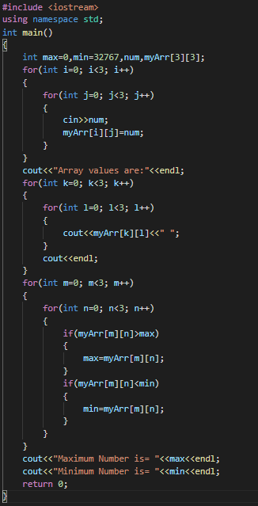

OUTPUT:-
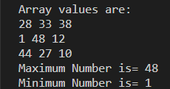

QNO #02:-

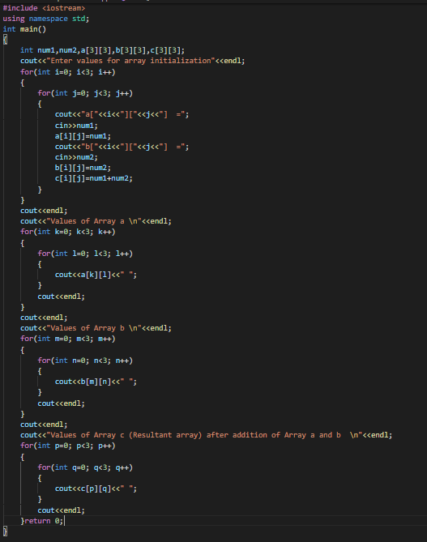

OUTPUT:-
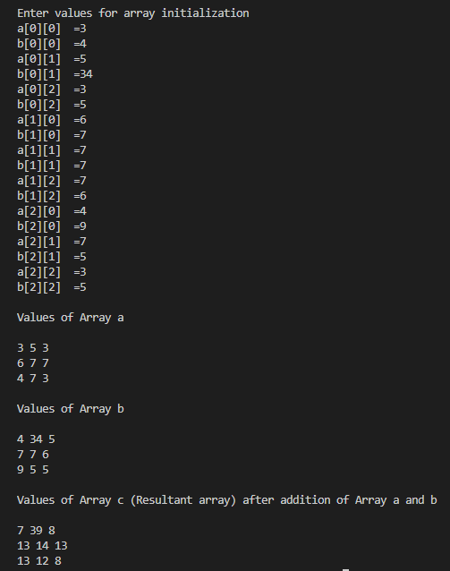

QNO #03:

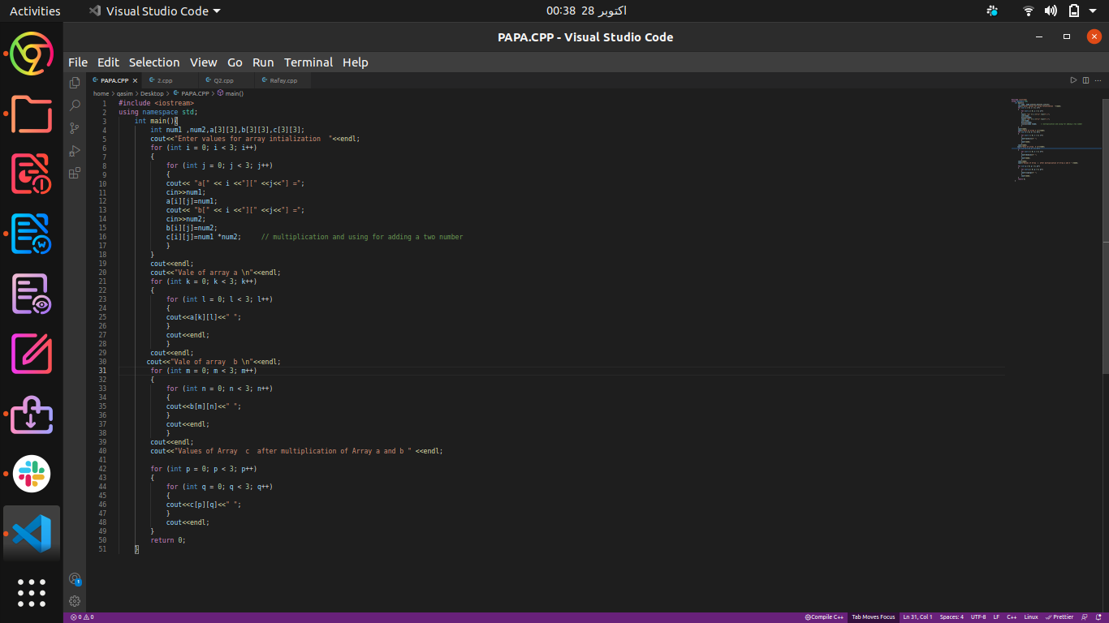

OUTPUT :-

